1. Retrieve the total number of orders placed.

select count(order_id) as Total_order from orders;



1. Calculate the total revenue generated from pizza sales.

SELECT

ROUND(SUM(order_details.quantity * pizzas.price),2) AS Total_revenue

FROM

order_details

JOIN

pizzas ON order_details.pizza_id = pizzas.pizza_id;

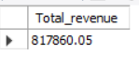

1. Identify the highest-priced pizza.

SELECT

pizza_types.name, pizzas.price

FROM

pizza_types

JOIN

pizzas ON pizza_types.pizza_type_id = pizzas.pizza_type_id

ORDER BY pizzas.price DESC

LIMIT 3;

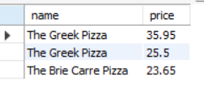

1. Identify the most common pizza size ordered.

SELECT

pizzas.size, COUNT(order_details.order_id) AS order_count

FROM

order_details

JOIN

pizzas ON order_details.pizza_id = pizzas.pizza_id

GROUP BY pizzas.size

ORDER BY order_count DESC

LIMIT 3;

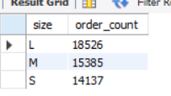

1. List the top 5 most ordered pizza types along with their quantities.

SELECT

pizza_types.name,

SUM(order_details.quantity) AS Total_order_Quantity

FROM

pizza_types

JOIN

pizzas ON pizzas.pizza_type_id = pizza_types.pizza_type_id

JOIN

order_details ON order_details.pizza_id = pizzas.pizza_id

GROUP BY pizza_types.name

ORDER BY Total_order_Quantity DESC

LIMIT 5;

